**Network Scanning Report**

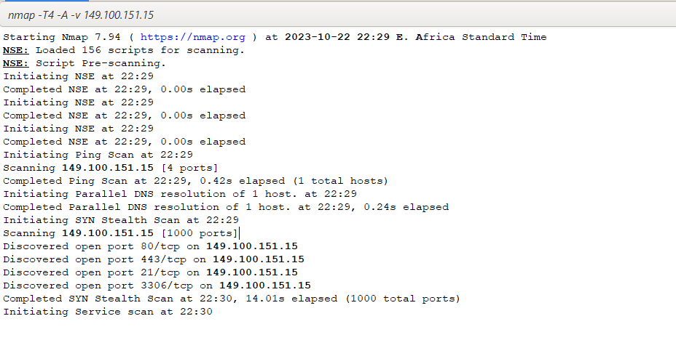

**Summary of Scan Results**

* The Nmap scan was conducted on the target host with the IP address 149.100.151.15. The scan took place on 22nd/10/2023 at 2230hrs.

Discovered Open Ports:

* Port 80/tcp: This port is commonly used for HTTP web traffic. The presence of this open port suggests the likelihood of a web server running on the target host.
* Port 443/tcp: Port 443 is typically used for secure HTTPS web traffic. Its presence implies that the target host may support secure web communication.
* Port 21/tcp: Port 21 is usually associated with FTP (File Transfer Protocol). The open port suggests that the target host has an FTP service running, enabling file transfers.
* Port 3306/tcp: Port 3306 is generally used for MySQL database traffic. The presence of this open port indicates that the target host might be running a MySQL database server.

Significance of Findings:

* The presence of ports 80 and 443, associated with HTTP and HTTPS, respectively, indicates the presence of a web server. This is significant as it suggests that the target host is likely serving web content.
* The open port 21 for FTP implies that the target host supports FTP file transfer services. This can be crucial for transferring files to and from the host.
* The existence of port 3306 for MySQL indicates that the target host is running a MySQL database service. This is vital information for potential database access and management.

These findings are essential for understanding the services offered by the target host and can be valuable for further analysis, security assessments, or troubleshooting.